How to create a mail merge

First you need to create a mailing list from the week 24 database spreadsheet. Please do a save as to create another document. You then need to sort the spreadsheet by column L so that all the generator are captured in one letter (if there are more than 10 generators you will need to create two letters for the recipient as the mail merge does not recognise too many. Please see the example below:

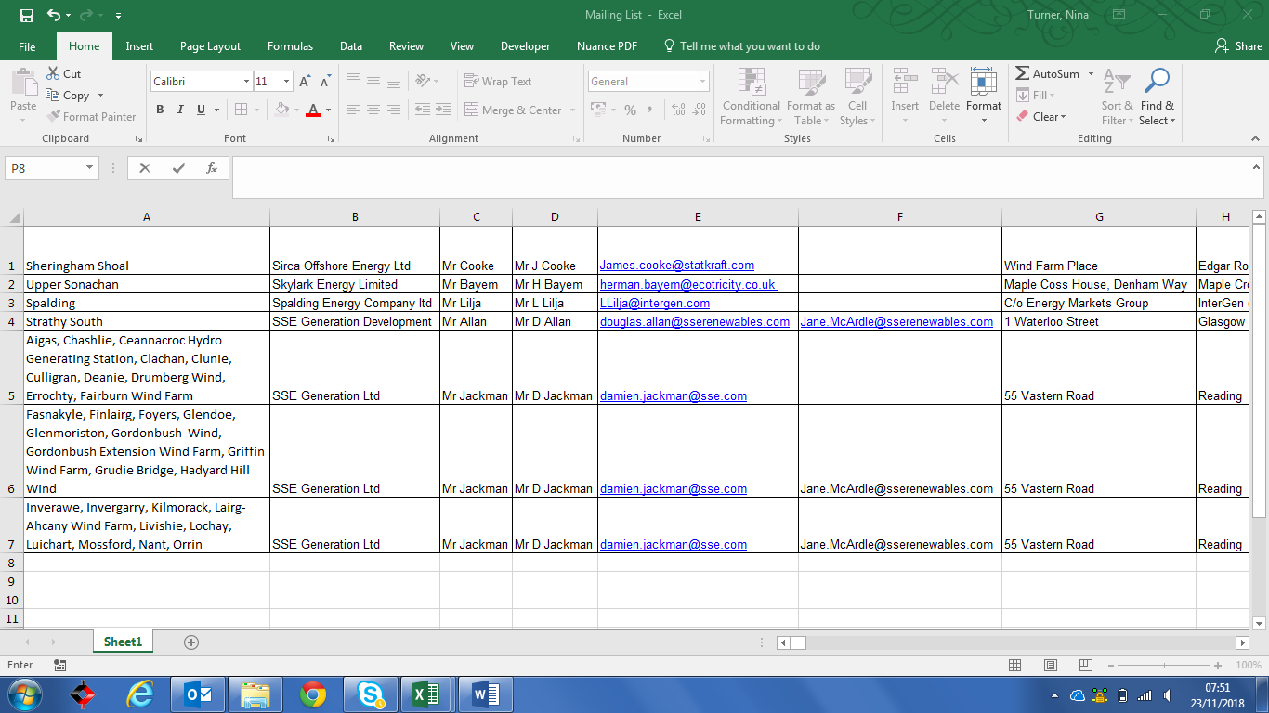

You then need to create the merge letter using the mailing tab as above click on the start mail merge tab and select the start mail merge wizard option.

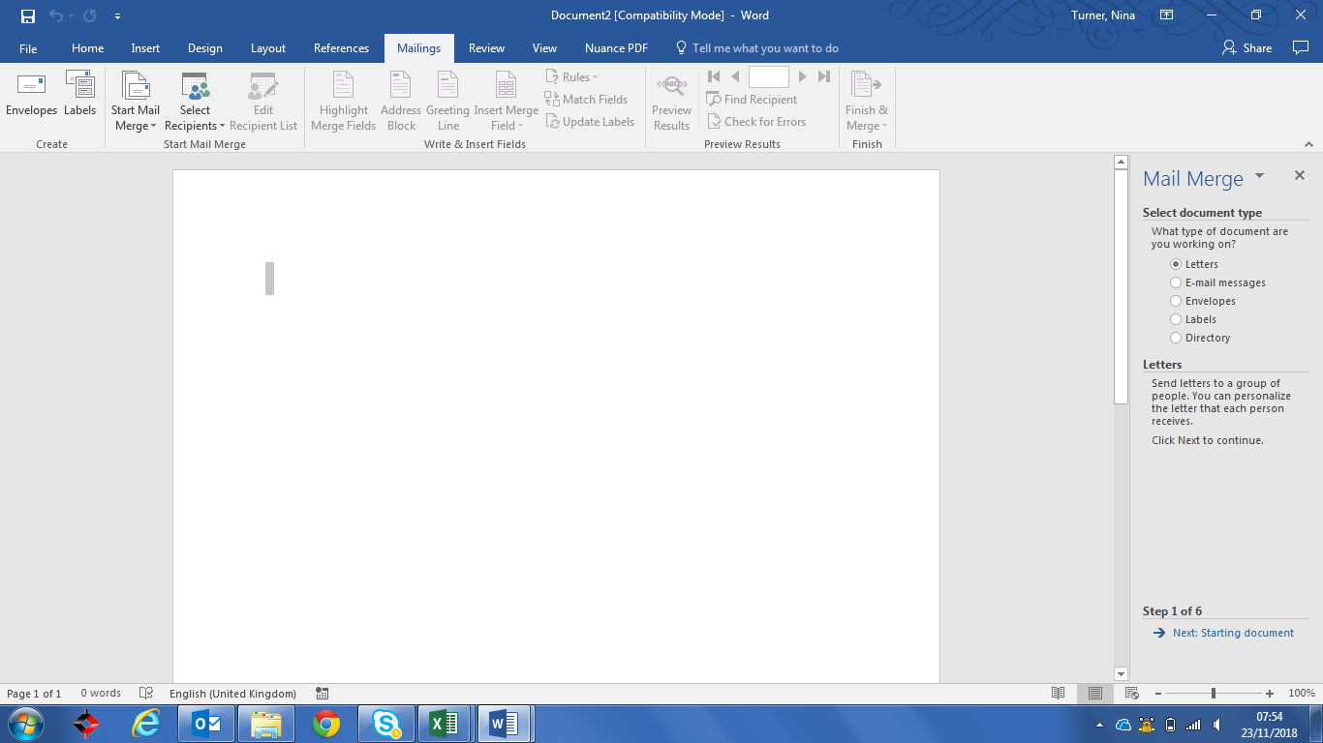

Click on the next starting document tab at the bottom right hand side. This will take you to the next screen and select use the current document and then select recipients on the bottom right hand side.

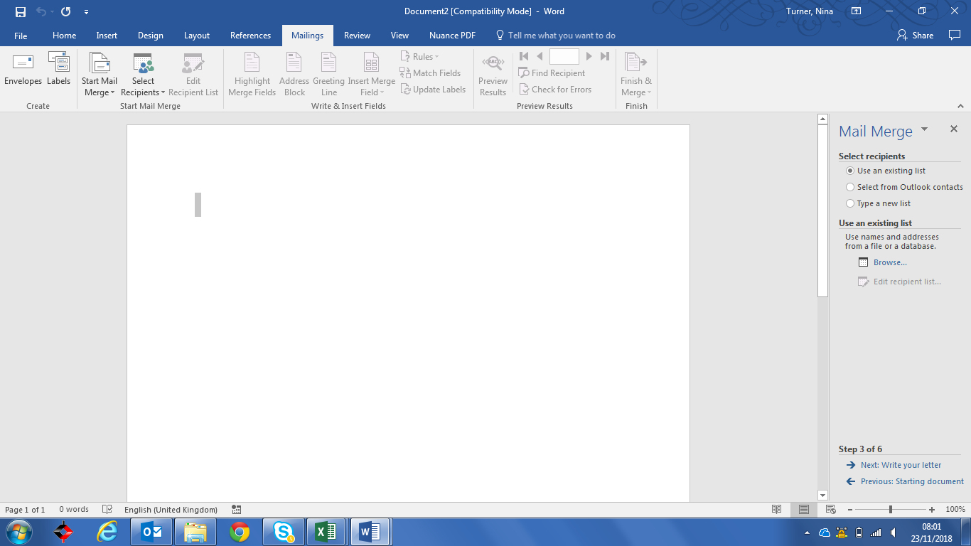

This will then open your document folder and you need to select the mail merge excel spread sheet that you have created.

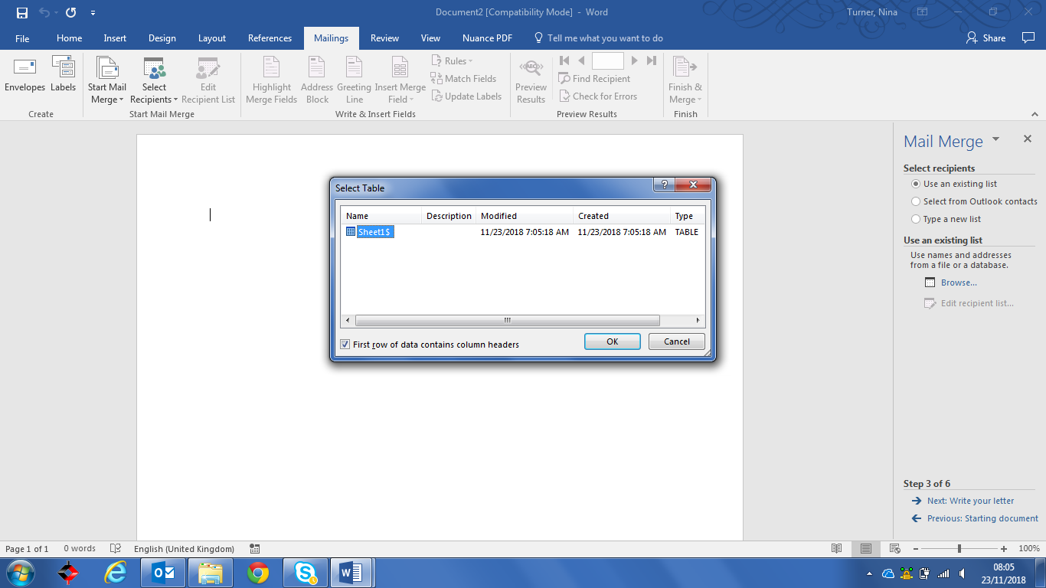

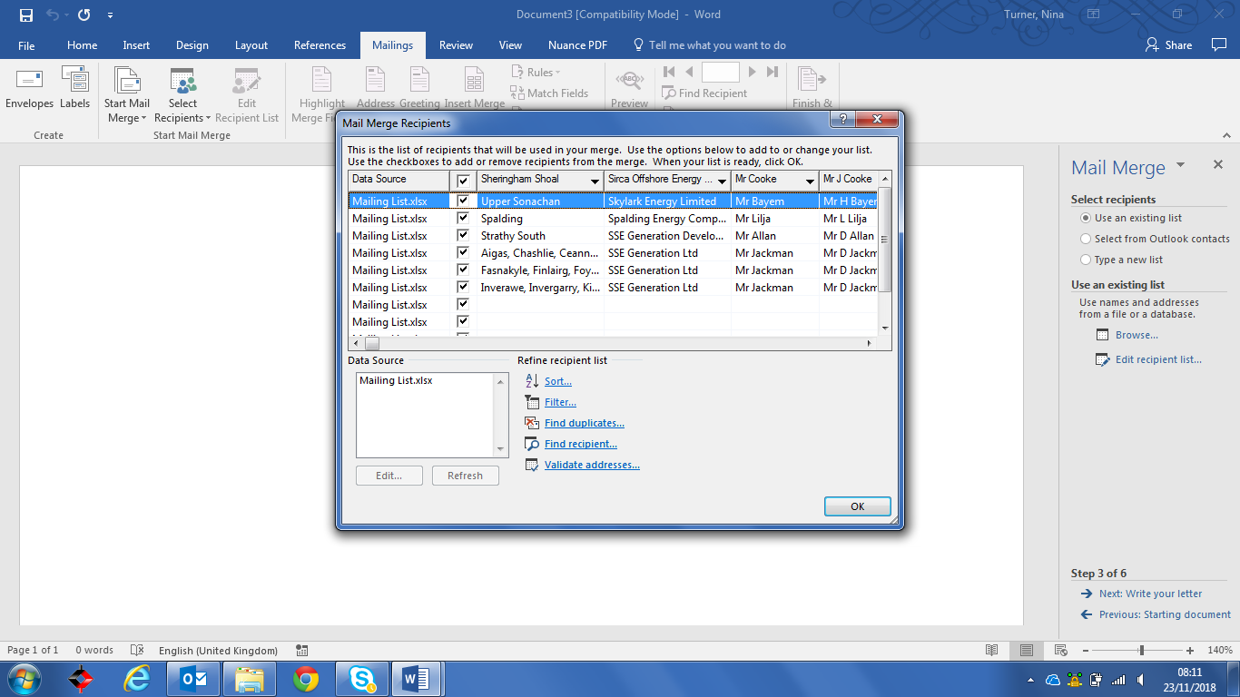

Click on OK and this will then open the mailing list so that you can write your letter. Click on Ok again

You then have the option to select which merge field you require for your letter. You must ensure that you use the headings as in the mailing list otherwise it will not work.

You need to insert the merge fields in the order at below: select more Items in the order that you would like to address your letter.

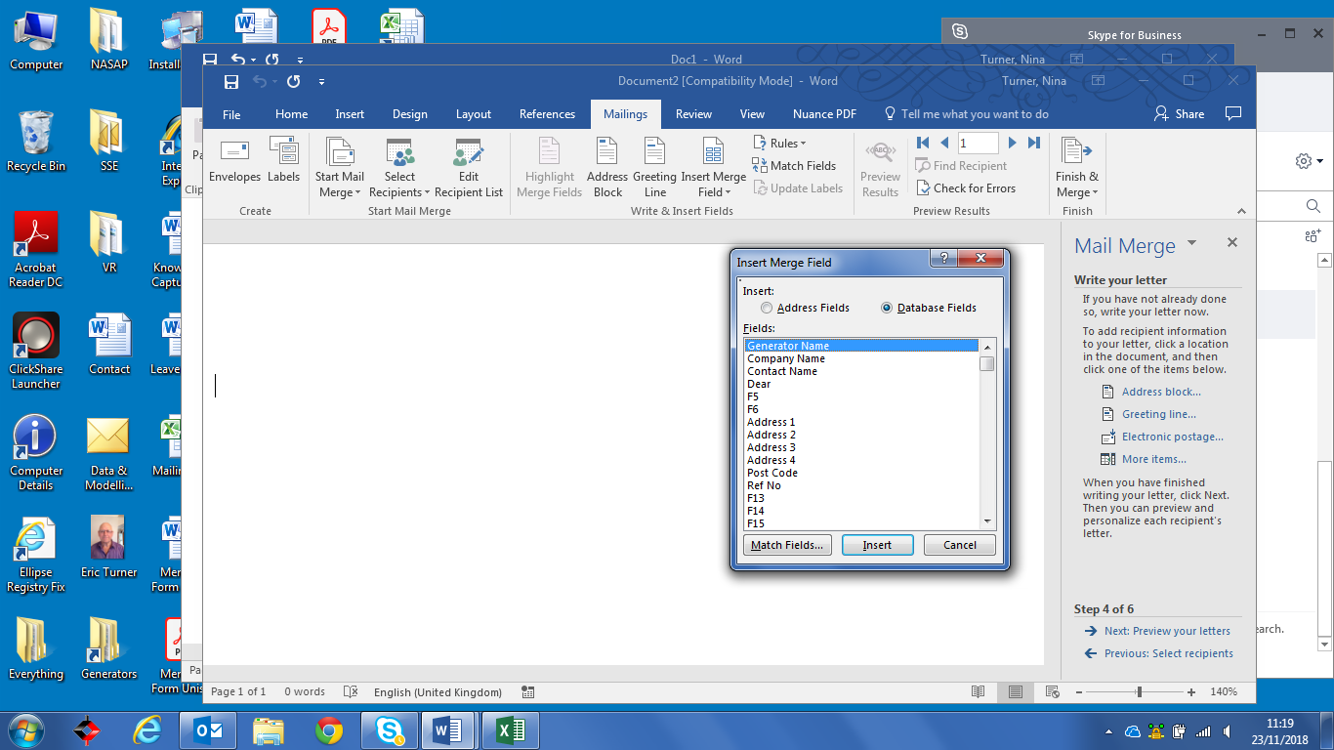

Select each Item to be inserted in the relevant part of the letter as per the example below:

|  |  |
| --- | --- |
| «Contact»  «Company»  «Address_1»  «Address_2»  «Address_3»  «Address_4»  «Post_Code»«Address_4» | **Insert Managers Name**  System Modelling Manager  Direct tel: +44 (0)1926 65  Submissions and queries to:  [data.submissions@nationalgrid.com](mailto:data.submissions@nationalgrid.com) |
|  | [www.nationalgrid.com](http://www.nationalgrid.com) |
| **Insert Date** |  |
| Our Reference: «Ref_No» |  |
|  |  |

Dear «First_Name»

**SUBMISSION OF GRID CODE WEEK 24 DATA FOR CONNECTION SITE(S): «Generator_Name»**

As a signatory to one or more generation agreements within the Connection and Use of System Code, your company now has an obligation to submit **Standard Planning Data (SPD)** and **Detailed Planning Data (DPD)** relating to the above sites by (**example of date to be inserted** **15th June 2018)**. This data should be complete and fully updated in accordance with Grid Code PC.4.3.1 to facilitate preparation by National Grid of the 2018 Electricity Ten Year Statement. The sometimes challenging requirement to provide DPD for projects up to seven years in the future, is recognised at PC.4.4.2 in allowing developers to submit DPD I data which may in turn need to be estimated in accordance with PC.A.1.11.

**SPECIFICATION OF GB TRANSMISSION SYSTEM PEAK AND MINIMUM DEMAND TIMES FOR THE ABOVE SITES**

Additionally, the Grid Code (PC.A.5.2.3) requires National Grid to provide a specification of the times of GB Transmission System peak and minimum demand to all Users in Week 17 each year.

The specification of the times of GB Transmission System peak and minimum demand is as follows:

**This information is obtainable from** [Joaquin.Jimenez@nationalgrid.com](mailto:Joaquin.Jimenez@nationalgrid.com)

|  |  |  |  |  |
| --- | --- | --- | --- | --- |
| FINANCIAL YEAR | PEAK OF GB TRANSMISSION SYSTEM DEMAND (UNDER ACS CONDITIONS) | | MINIUMUM OF GB TRANSMISSION SYSTEM DEMAND (UNDER AVERAGE CONDITIONS) | |
|  | TIME | DATE | TIME | DATE |
| 2018/2019 |  |  |  |  |
| 2019/2020 |  |  |  |  |
| 2020/2021 |  |  |  |  |
| 2021/2022 |  |  |  |  |
| 2022/2023 |  |  |  |  |
| 2023/2024 |  |  |  |  |
| 2024/2025 |  |  |  |  |
| 2025/2026 |  |  |  |  |

The dates specified above for peak GB Transmission System demand correspond to demands that are expected under ACS conditions. Historically ACS conditions occur in December when demands are at their highest, and temperatures near their coldest.

The table below details the actual peak and minimum demand for the year 2017/18:

**This information is also obtainable from Joaquin.Jimenez**

|  |  |  |  |
| --- | --- | --- | --- |
|  | Date | Half Hour Ending | Demand (GW) |
| Actual Peak |  |  |  |
| Actual Minimum |  |  |  |

I would be grateful if you would also prepare your demand data submissions in line with the above specified dates and ensure that all submissions are made no later than week 24, (week ending 15 June 2018).

Submissions should be made on the Data Registration Code (DRC) template and sent to [data.submissions@nationalgrid.com](mailto:data.submissions@nationalgrid.com). This year we are trialling a new template in Excel which we hope you will find easier to use. To assist you to prepare your submission guidance notes are attached.

If a full submission of **Detailed Planning Data (DPD)** in accordance with the requirements has previously been made to National Grid and there has been no change in submitted data since the last submission please would you confirm that this is the case (Grid Code PC 4.3.1 refers). A reply to the email address above stating this fact is acceptable.

Additionally if Detailed Planning Data Phase II (DPDII) is currently in the process of being submitted as a User Data Library in pursuance of a pending Operational Notification, confirmation of the identity National Grid recipient of this information to the e-mail address below is sufficient.

If the contact and address used is incorrect we would be grateful for clarification of the correct information to [data.submissions@nationalgrid.com](mailto:data.submissions@nationalgrid.com)

Please do not hesitate to contact **Insert your name and contact number** or via email [data.submissions@nationalgrid.com](mailto:data.submissions@nationalgrid.com) if you have any queries or feedback.

Yours sincerely

**Insert Managers Name**

System Modelling Manager

Skip the next stage in the mail merge and got to complete the merge.

You can then edit each individual letter and then print in PDF format so it cannot be altered.

It then need to be sent out to the individual recipient as in the email address section.